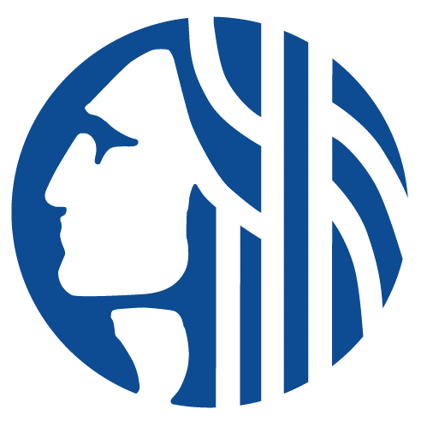

CENTRAL WATERFRONT OVERSIGHT COMMITTEE
Wednesday, May 1st, 2024
11:30am-1:00pm
In person: Mithun – Orca Room
Virtual: Teams info below
Agenda
- Welcome and meeting protocols/public comment opportunities
- Friends 2023 Recap
- SDOT Right-of-Way Maintenance & Funding
- Annual Report Update
- Park Inspection results + Experience based feedback (Owen Harrang)

Teams Meeting Info: Join on your computer, mobile app or room device
Click here to join the meeting
Meeting ID: 258 403 326 415
Passcode: LuMnEu
Download Teams | Join on the web
Join with a video conferencing device
seattle@m.webex.com
Video Conference ID: 116 146 180 1
Alternate VTC instructions
Or call in (audio only)
+1 206-686-8357,,400389647# United States, Seattle
Phone Conference ID: 400 389 647#

